Agent Development Plan – Plans App
Oct 26, 2026 · @aleixRC

Summary and proposal
I propose two specialized builder agents (Backend and Frontend) working in parallel, preceded by an Architect agent that sets the contract between them and followed by two reviewer agents (QA and Security).
Splitting into front and back is a good idea, but it only works if a closed contract exists first: data model, endpoints, error formats and shared validation schemas. Without it, each agent invents its own version of the API and integration becomes the most expensive phase.
The reviewers are different agents from the ones writing the code. An agent reviewing its own work tends to approve it, especially on security and concurrency cases.
Reference stack: React + Vite + TypeScript, NestJS, PostgreSQL with Prisma, Redis and Docker Compose, in a monorepo. Verification emails go out through a transactional email provider and are captured locally with Mailpit.

Agent team
Five agents with non-overlapping responsibilities. Only three of them write product code.
Agent | When it acts | Responsibility | What it does NOT do
Architect | Phase 0, and afterwards only on request | Monorepo, shared package (types, enums, Zod schemas), Prisma schema, OpenAPI spec, Docker Compose, base CI | Does not implement business logic or screens
Backend | Phases 1–3 | NestJS API: auth with email verification, users, event templates, calendar, attendance, image upload, security | Does not touch apps/web or change the contract on its own
Frontend | Phases 1–3 | React SPA: layout and sidebar, calendar, side panel, context menu, Events module, login, sign-up and email verification | Does not touch apps/api or change the contract on its own
QA | Phase 2 | E2E tests with Playwright, concurrency and permission tests, bug reports | Does not fix code: opens issues for Backend or Frontend
Security | Phase 3 | Review of the backend and configuration against the OWASP Top 10, rate limiting, uploads and sessions | Does not fix code: delivers prioritized findings
To reduce cost, QA and Security can be a single reviewer agent. What you should avoid is the reviewer being the same agent that wrote the code.

Repository structure
Each folder has a single owning agent, so two agents working in parallel never edit the same file.
/apps/api → Backend (NestJS)
/apps/web → Frontend (React + Vite)
/packages/shared → Architect (types, enums, Zod schemas)
/prisma → Architect (schema.prisma and initial migrations)
/docs/openapi.yaml → Architect (API contract)
/infra → Architect (docker-compose, Caddy, .env.example)
/e2e → QA (Playwright)
Migrations after Phase 0 are written by Backend, but any schema change that affects the contract goes through the Architect first.

Phases and dependencies
The only mandatory sequential phase is the contract; from there, Backend and Frontend move forward at the same time.
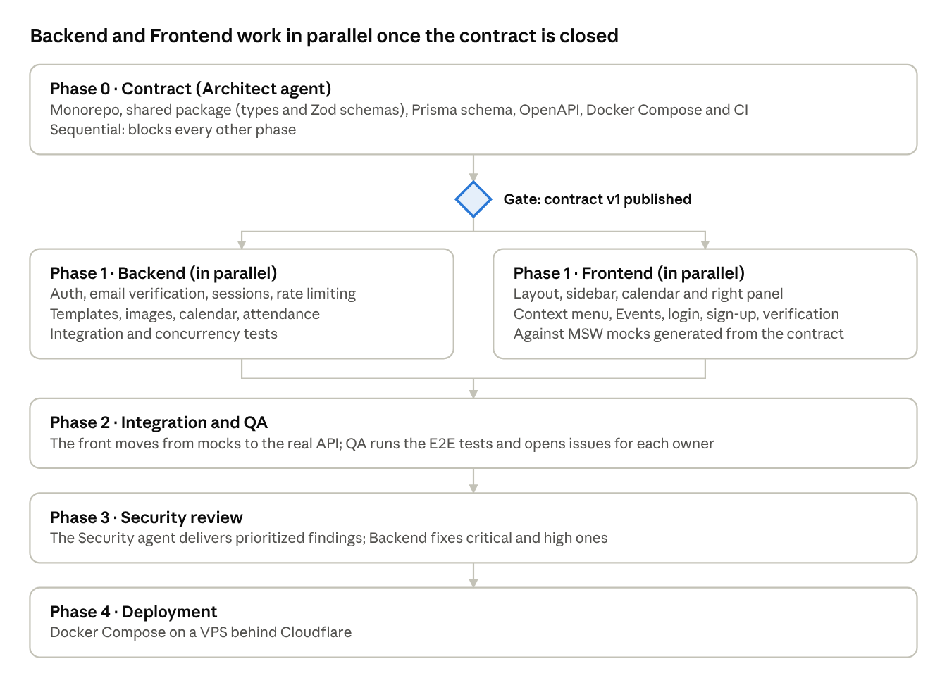
development phases · 5 phases, 1 gate
Phase 1 is the longest, and it is where parallel work saves time. Phases 2 and 3 are short if the contract was respected.

Phase 0 – Contract (Architect agent)
Phase 0 ends when contract v1 is published in the repo and Backend and Frontend can start without asking anything. It is the only phase that blocks all the others.
Data model
Table | Main fields | Database rules
users | id, username, email, email_verified_at, password_hash, created_at | username (3–30 characters) and email unique; email stored lowercase; no login without email_verified_at
email_verification_tokens | id, user_id, token_hash, expires_at, used_at, created_at | only the token hash is stored; expires after 24 h; single use
event_templates | id, owner_id, name, description, type, image_url, attendees, start_time, end_time | name, description and type required; type is an enum
calendar_entries | id, template_id, date, capacity, added_by, created_at | capacity between 1 and 10; max 4 per date (checked inside a transaction)
attendances | entry_id, user_id, created_at | composite primary key: nobody signs up twice
EventType enum: LAN_PARTY, JUEGO_ONLINE, PLAN_GATO, DND, PASEO, PSICOLOGO, PELUQUERIA, OTROS. The Spanish display labels live in shared (the UI is in Spanish).
Endpoints
Method and route | Access | Purpose
POST /auth/register | Public + CAPTCHA | Create an unverified user and send the verification email (does not start a session)
POST /auth/verify-email | Public | Verify the account with the token from the link
POST /auth/resend-verification | Public, strict rate limit | Resend the email; always a generic response
POST /auth/login | Public, strict rate limit | Log in (cookie); 403 EMAIL_NOT_VERIFIED if the account is not verified
POST /auth/logout | Authenticated | Log out
GET /auth/me | Public | Current user or null
GET /event-templates | Authenticated | List templates
POST /event-templates | Authenticated | Create a template
PATCH /event-templates/:id | Owner | Edit a template
DELETE /event-templates/:id | Owner | Delete a template
POST /uploads/image | Authenticated | Upload an image, returns its URL
GET /calendar?from&to | Public | Entries in the range with their template and attendees
POST /calendar/entries | Authenticated | Add a template to a day with capacity 1–10
DELETE /calendar/entries/:id | The user who added it | Remove the event from the day
POST /calendar/entries/:id/attendance | Authenticated | Sign up
DELETE /calendar/entries/:id/attendance | Authenticated | Withdraw
Phase deliverables
- ☐ Monorepo with pnpm workspaces, strict TypeScript, ESLint and Prettier
- ☐ packages/shared: enums, types and Zod schemas for every request and response
- ☐ schema.prisma with an initial migration and seed data
- ☐ openapi.yaml with every endpoint, status codes and a single error format { code, message, details? }
- ☐ Docker Compose with PostgreSQL, Redis, MinIO and Mailpit (captures emails locally); .env.example
- ☐ CI that runs lint, typecheck and tests on every change

Email verification
On sign-up the account is created but stays inactive until the user clicks the link they receive by email. Without verifying they cannot log in, so they cannot create events or sign up for them either.
Flow
- The user signs up with username, email, password and CAPTCHA. The API creates the user with an empty email_verified_at, generates a random 32-byte token, stores only its SHA-256 hash with a 24-hour expiry, and sends the email. No session is started.
- The response is always the same ("If the details are valid, you will receive an email"), whether or not that email already exists, so it never reveals which emails are registered. If the email already had an account, the message tells them so instead of including a link.
- The link points to the web app (/verificar-email?token=…), not to the API. The page sends the token with a POST when it loads. That way spam filters that open links automatically do not consume the token.
- The API checks the hash, the expiry and that the token has not been used, and sets email_verified_at and used_at in the same transaction. If anything fails it responds 400 INVALID_OR_EXPIRED_TOKEN, with no further detail.
- If someone logs in with the correct password but an unverified account, they get 403 EMAIL_NOT_VERIFIED and the option to resend. This check happens only after the password has been validated.
- Resending invalidates previous tokens and creates a new one. Limit: 1 per minute and 5 per day per email, on top of the per-IP limit. The response is generic too.
Sending emails. The backend has a mail module with a single interface and two implementations: SMTP against Mailpit locally, and the chosen provider in production. Templates are in Spanish, in plain text and simple HTML. If the provider fails, sign-up does not break: the error is logged and the user can request a resend.

Backend agent tasks
Backend implements the contract in this order, because each block depends on the previous one: identity first, then data, and finally the capacity rules.
- Base and cross-cutting security: NestJS with Helmet, CORS restricted to the domain, request body size limit, global validation with the shared schemas, rejection of unknown fields, a single error format and structured logging.
- Auth and users: sign-up with CAPTCHA (Turnstile), Argon2id password hashing, session in an httpOnly, Secure, SameSite=Lax cookie stored in Redis, CSRF token, /auth/me and logout. Generic message on failed logins.
- Email verification: mail module (SMTP against Mailpit locally, provider in production), random tokens stored as hashes with a 24-hour expiry and single use, login blocked until verified, resend limited per email and IP, and generic responses that never reveal whether an email exists. Follows the flow in the Email verification section.
- Rate limiting: @nestjs/throttler with Redis. Strict limit on login, sign-up and verification resend (per IP and per username), progressive delay after failures, and a general per-IP limit for everything else.
- Event templates: CRUD with an owner guard on PATCH and DELETE (403 if not the author).
- Images: upload with a 5 MB limit, real file-type check, re-encoding with sharp to WebP, random name and storage in MinIO/S3.
- Calendar: listing by date range (max 6 weeks per query) and adding entries. The same transaction locks the date and checks the 4-event maximum. Only added_by can delete.
- Attendance: sign up and withdraw. The entry row is locked with SELECT … FOR UPDATE, attendees are counted against capacity, and 409 is returned if it is full.
- Tests: service unit tests, integration tests against real PostgreSQL (Testcontainers), verification flow tests (expired, reused or tampered token, and login before verifying), and a concurrency test that fires 20 simultaneous sign-ups at a capacity of 3 and checks that only 3 get in.
Definition of done: every endpoint in openapi.yaml responds according to the spec and the tests pass in CI.

Frontend agent tasks
Frontend does not wait for Backend: it works against a mock server (MSW) generated from openapi.yaml and the shared schemas. In Phase 2 it swaps the mocks for the real API.
- Base: Vite + React + TypeScript, Tailwind, shadcn/ui, React Router, TanStack Query and a typed HTTP client that sends cookies and the CSRF token.
- Layout: sidebar with Calendario, Eventos and Identificarse. Eventos is only accessible with a session. Identificarse turns into the username and "Cerrar sesión" after login.
- Monthly calendar: grid built with date-fns, month navigation and up to 4 visible events per cell (name and type).
- Right panel: "No hay evento seleccionado" by default. Clicking an event shows its image, name, description, type, schedule, capacity and attendee list, with a sign up / withdraw button and a Full state once it fills up.
- Context menu (right click) with shadcn's ContextMenu. "Añadir evento" opens a dialog to pick the template and capacity (1–10) and is disabled if the day already has 4. "Eliminar evento" shows a submenu with the events the user added and does not appear if there are none. Without a session, the menu does not open.
- Events module: creation form (image, name*, description*, type*, attendees, start and end time) with React Hook Form and Zod, and a list with editing and deletion only for the user's own templates.
- Login and sign-up: simple forms with Turnstile on sign-up (username, email and password) and clear error messages. After signing up, a "Check your email" screen is shown; if login responds that the email is not verified, it offers to resend it.
- Verification page (/verificar-email): reads the token from the URL, sends it with a POST on load, and shows either account verified (with a link to Identificarse) or link expired (with a resend button). Uses Referrer-Policy: no-referrer so the token does not leak to other sites.
- States and accessibility: loading, error and empty states in every view, keyboard navigation of the context menu and alt text on images.
- Tests: components with Vitest and Testing Library, especially the right panel and the menu permissions.
Definition of done: every screen works against the mocks and the visible permissions match the contract.

Integration, QA and security review
In Phase 2 the front is connected to the real API and QA validates the full flows. In Phase 3, Security reviews with fresh eyes and Backend fixes.
QA agent: E2E scenarios with Playwright
- ☐ A visitor without a session sees the calendar and the panel, but not the context menu, Eventos, or the sign-up button
- ☐ Full sign-up, login and logout
- ☐ Sign-up → email captured in Mailpit (through its API) → verification link → account verified → successful login
- ☐ Login before verifying is rejected; expired or already-used link is rejected; resend blocked once the limit is exceeded
- ☐ Create a template with an image and check that another user cannot edit or delete it
- ☐ Add 4 events to a day and verify that the fifth is rejected
- ☐ Fill the capacity and check that the next user sees Full
- ☐ Only the user who added an event to a day can remove it
- ☐ Call the API directly, bypassing the UI, for every forbidden action and check for 401 or 403
Security agent: review checklist
- ☐ Authorization on every endpoint that modifies data (IDOR: changing another user's id)
- ☐ Effective rate limiting on login and sign-up, including rotating IPs per username
- ☐ Email verification: tokens stored only as hashes, with expiry and single use; no email enumeration in sign-up, login or resend; the token never appears in logs or leaks through the Referer header
- ☐ Correct cookies, CSRF, CORS and Helmet/CSP headers
- ☐ Image upload: disguised files, large sizes, SVG with scripts
- ☐ Paginated or bounded queries: no request returns unbounded data
- ☐ Audited dependencies and secrets kept out of the repository
- ☐ Caddy and Cloudflare configuration: timeouts, max request size and basic WAF rules
Security delivers prioritized findings (critical, high, medium). Backend fixes critical and high findings before deployment.

Coordination rules
These rules prevent the two typical problems of multi-agent work: overwritten files and diverging contracts.
- The contract is the source of truth. If Backend or Frontend need to change it, they open a request to the Architect, who updates shared and openapi.yaml and bumps the version. Nobody edits the contract directly.
- Folder ownership. Each agent only writes in its own folders (see Repository structure).
- One branch per agent and task, with small changes. A change is merged only if CI passes.
- Startup context. Each agent receives this document, the current contract and its task list; it is never asked to infer anything from another agent's code.
- Issues, not cross-patches. QA and Security report; the code owner fixes.
Definition of done (for any task)
- ☐ Meets the contract and the criteria in its section
- ☐ Has tests and CI is green
- ☐ Lint and typecheck with no errors
- ☐ Permissions are enforced on the server, not only in the UI

Open decisions before starting
The Architect needs these answers to close contract v1. Each one includes the option I propose by default.
- ☐ Attendees in the template and in the calendar. Proposal: the template value is the default for the 1–10 dropdown when adding it to a day.
- ☐ Editing or deleting a template already used in the calendar. Proposal: edits are reflected in the entries, and deletion is blocked while the template is in use.
- ☐ Lowering capacity below the number already signed up. Proposal: not allowed; capacity is fixed once the entry is added.
- ☐ Start and end time. Proposal: they are times of day (no date) inside the template; the calendar provides the date.
- ☐ Hosting. Proposal: a VPS with Docker Compose behind Cloudflare, with images in Cloudflare R2.
- ☐ Email provider. Proposal: Resend or Postmark, whose free plans are enough at first, with your own domain configured with SPF, DKIM and DMARC so emails do not end up in spam.
- ☐ Unverified accounts. Proposal: deleted automatically after 7 days, freeing the username and email.
- ☐ Email change and password recovery. Proposal: out of scope for v1, although the mail module and the tokens table lay the groundwork for adding them.

